 | Department of Computer Science  Faculty of Computing  UNIVERSITI TEKNOLOGI MALAYSIA

SUBJECT NAME: | COMPUTER ORGANIZATION AND ARCHITECTURE
SUBJECT CODE: | SECR 1033
SEMESTER: | 2 – 2023/2024
LAB TITLE: | Lab 2: Arithmetic Equations & Operations
STUDENT INFO: | Execute the lab in group of two.  Student 1 Student 2  No. 1, 3, 5 No 2, 4, 6  Name 1: Nabil Aflah Boo Bt Mohd Yosuf Boo Yong Chong  Metric No: A23CS0252  Link for Video Demo: https://drive.google.com/drive/folders/1D9ndZ_6NrRkQ4ieQiv-mqKF_1dB1gcpC?usp=sharing  Name 2: Nurul Adriana Binti Kamal Jefri  Metric No: A23CS0258  Link for Video Demo: https://drive.google.com/drive/folders/1dDTkOXd-1uT7d3rHvxo5AwKkfR9Ag9ff?usp=drive_link
SUBMISSION DATE & ITEMS: | Duration of submission: -  2 weeks  Submission items in e-learning: -  1. Lab 2 exercise sheet/file (in .pdf), with the links for demo video 5 - 10min, on the cover page.  2. The assembly programs (in.asm).

MARKS:
________

Arithmetic Equation Coding in Assembly Language

Q1. Execute the program below. Determine output of the program by inspecting the content of the related registers.

- Fill in Table 1 with the content of each register or variable on every LINE, in Hexadecimal (as per the output). Please complete the comments for every LINE.
- Paste the screenshot of all registers’ content after each LINE is executed.

INCLUDE Irvine32.inc
.data
var1 word 1
var2 word 9

.code
main PROC
mov ax, var1 ; LINE1
mov bx, var2 ; LINE2
xchg ax, bx ; LINE3
mov var1, ax ; LINE4
mov var2, bx ; LINE5
call DumpRegs
exit
main ENDP
END main

Answer Q1

a) Fill (Write) in the contents for the related register in each line:
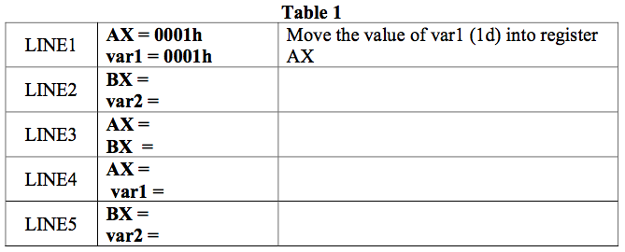
0001h
0001h
0009h
0009h
0009h
0001h
0009h
0009h
Move the value of register BX into var2
Move the value of register AX into var1
Exchange the register BX with register AX
Move the value of var2 into register BX

b) Paste here screenshot of all registers’ content after each LINE is executed:

LINE 1:
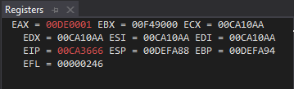

LINE 2:
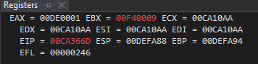

LINE 3:
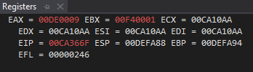

LINE 4:
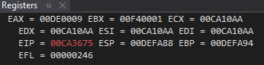

LINE 5:
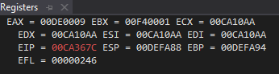

Q2. Execute the program below. Determine output of the program by inspecting the content of the related registers and watches.

- Fill in Table 2 with the content of each register or variable on every LINE, in Hexadecimal (as per the output). Please complete the comments for every LINE.
- Paste the screenshot of all registers’ content after each LINE is executed.

Arithmetic expression: Rval = (-Xval + (Yval – Zval)) + 1

include irvine32.inc

.data
Rval DWORD ?
Xval DWORD 26
Yval DWORD 30
Zval DWORD 40

.code
main proc
mov eax,Xval ; LINE1
neg eax ; LINE2
mov ebx,Yval ; LINE3
sub ebx,Zval ; LINE4
add eax,ebx ; LINE5
inc eax ; LINE6
mov Rval,eax ; LINE7
exit
main endp
end main

Answer Q2

- Fill (Write) in the contents for the related register in each line:

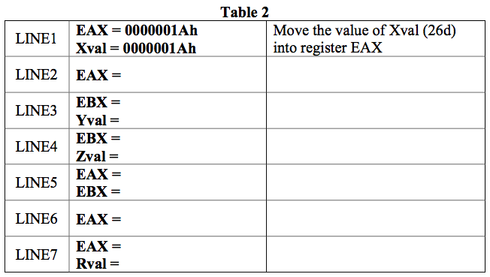
Move the value in EAX to Rval
Increment the value in EAX by 1
Move the value of Yval (30d) into register EBX
Subtract the value of Zval (40d) from EBX
Add the value of EBX to EAX
Negate the value in EAX
FFFFFFDDh

FFFFFFDDh

FFFFFFDDh

FFFFFFF6h

FFFFFFDCh

00000028h

FFFFFFF6h

0000001Eh

0000001Eh

FFFFFFE6h

b) Paste here screenshot of all registers’ content after each LINE is executed:

LINE 1:
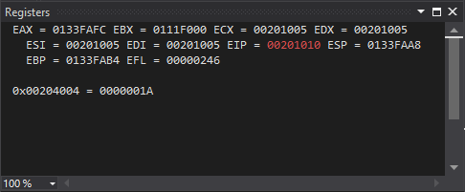

LINE 2:
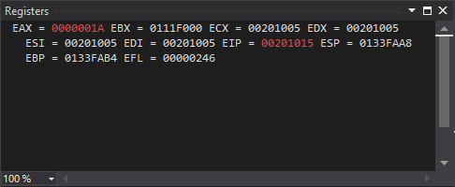

LINE 3:
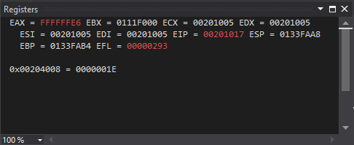

LINE 4:
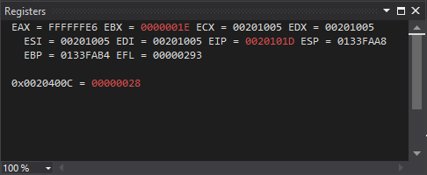

LINE 5:
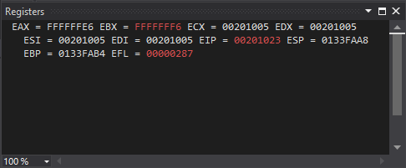

LINE 6:
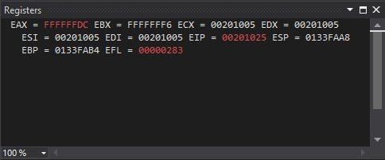

LINE 7:
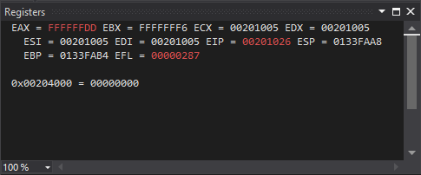

Q3. Execute the program below. Determine output of the program by inspecting the content of the related registers.

- Fill in Table 3 with the content of each register or variable on every LINE, in Hexadecimal (as per the output). Please complete the comments for every LINE.
- Paste the screenshot of all registers’ content after each LINE is executed.

Arithmetic expression: var4 = [(var1 * var2) + var3] - 1

include irvine32.inc

.data
var1 DWORD 5
var2 DWORD 10
var3 DWORD 20
var4 DWORD ?

.code
main proc
mov eax, var1 ; LINE1
mul var2 ; LINE2
add eax, var3 ; LINE3
dec eax ; LINE4
exit
main endp
end main

Answer Q3

- Fill (Write) in the contents for the related register in each line:
Table 3
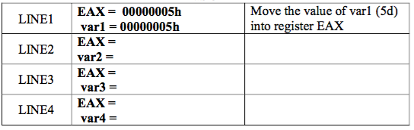
00000045h
00000069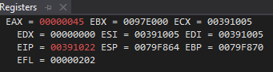h
00000046h
00000014h
00000032h
0000000Ah
Add the value of var3 with register EAX
Decrement with the register EAX
Multiply with the value of var2

b) Paste here screenshot of all registers’ content after each LINE is executed:

LINE 1:
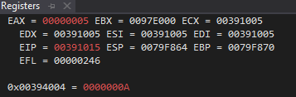

LINE 2:
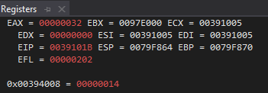

LINE 3:
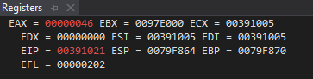

LINE 4:


Q4. Execute the program below. Determine output of the program by inspecting the content of the related registers.

- Fill in Table 4 with the content of each register or variable on every LINE, in Hexadecimal (as per the output). Please complete the comments for every LINE.
- Paste the screenshot of all registers’ content after each LINE is executed.

Arithmetic expression: var4 = (var1 * 5) / (var2 – 3)

include irvine32.inc
.data
var1 WORD 40
var2 WORD 10
var4 WORD ?
.code
main proc
mov ax,var1 ; LINE1
mov bx,5 ; LINE2
mul bx ; LINE3
mov bx,var2 ; LINE4
sub bx,3 ; LINE5
div bx ; LINE6
mov var4,ax ; LINE7
exit
main endp
end main

Answer Q4

- Fill (Write) in the contents for the related register in each line:
Table 4
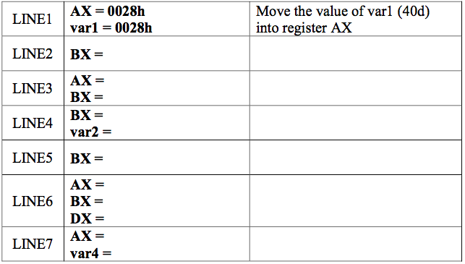
Move the value in register AX to var4
Divide DX
by BX, quotient in AX, remainder in DX
002Ch
002Ch
0007h
0007h
002Ch
0007h
Subtract integer value (3) from EBX

000Ah
Move integer value (5) into register BX
000Ah
Multiply register AX to register BX, and store into register AX
0005h
00C8h
Move integer value (5) into register BX
0005h

b) Paste here screenshot of all registers’ content after each LINE is executed:

LINE 1:
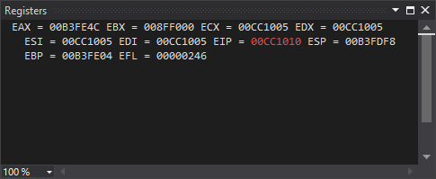

LINE 2:
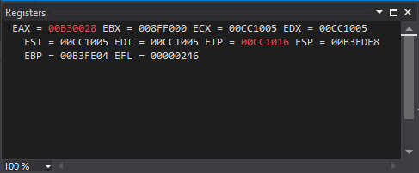

LINE 3:
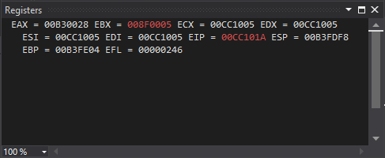

LINE 4:
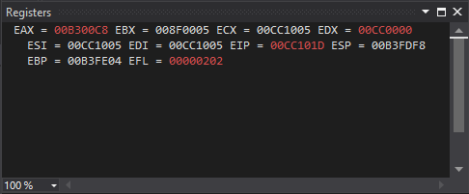

LINE 5:
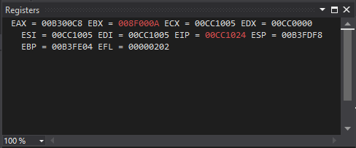

LINE 6:
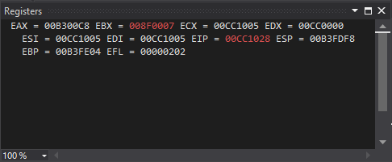

LINE 7:
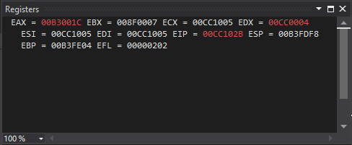

Short Notes for MUL CX and DIV BL:

MUL CX
- MUL always uses AX (or its extended versions EAX or RAX) as the implicit destination register.
- The operand size determines the size of the result:
- Byte-sized operand: Result in AX
- Word-sized operand: Result in DX:AX
- Doubleword-sized operand (32-bit mode): Result in EDX:EAX
- Quadword-sized operand (64-bit mode): Result in RDX:RAX
- The upper half of the result (DX or EDX or RDX) holds any overflow bits.
- The Carry Flag (CF) is set if the upper half of the product is non-zero.

DIV BL

- DIV always uses the DX:AX or EDX:EAX pair as the implicit dividend register.
- The divisor is specified as the operand of the DIV instruction.
- The quotient is stored in AX (for 16-bit division) or EAX (for 32-bit division).
- The remainder is stored in DX.
- Clear DX (or EDX for 32-bit division) before division to ensure a correct 16-bit or 32-bit dividend.
- If the divisor is 0, a division error occurs.
- The Overflow Flag (OF) is set if the quotient is too large to fit in the destination register.
________________________________________________

Q5. Given the following instructions as is Code Snippet 1.

- Write a full program to execute the Code Snippet 1.
- What are the contents of the related registers after Code Snippet 1 is executed? Paste the screenshot of DumpReg.

; Code Snippet 1 (MUL CX)

MOV DX,0 ; Clear DX
MOV AX,1000h ; Load 1000h into AX
MOV CX, 25h ; Load 25h into CX
MUL CX ; Multiply AX by CX, storing the result in DX:AX

Answer Q5

- Screenshot of full program (.asm):

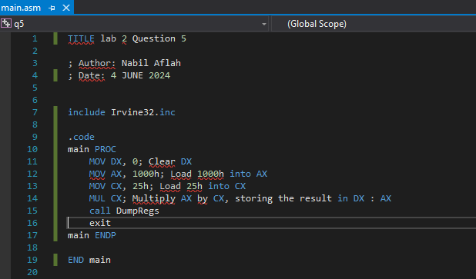

- Paste here the screenshot of the final registers’ content (DumpReg):

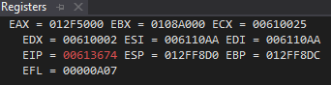

Q6. Given the following instructions as is Code Snippet 2.

- Write a full program to execute the Code Snippet 2.
- What are the contents of the related registers after Code Snippet 2 is executed? Paste the screenshot of DumpReg.

; Code Snippet 2 (DIV BL)
MOV DX, 0 ; Clear DX to form the 16-bit dividend in DX:AX
MOV AX, 803h ; Load the dividend (8003h) into AX
MOV BL, 10h ; Load the divisor (10h) into BL
DIV BL ; Divide DX:AX by BL, whereby AX=quotient & DX=remainder

Answer Q6

- Screenshot of full program (.asm):

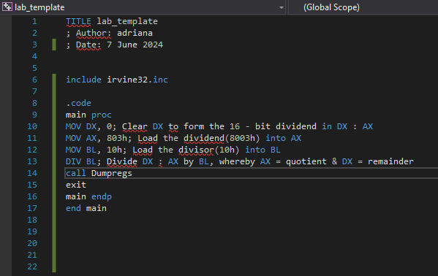

- Paste here the screenshot of the final registers’ content (DumpReg):

